A Project Report
on
CONSOLE-BASED EDUCATIONAL TOOL FOR NEPAL'S SATELLITES
Submitted in partial fulfillment of the requirement of PROJECT
PROJECT (156)
of
Postgraduate Diploma in Computer Application
II Semester

Submitted to
PURBANCHAL UNIVERSITY
Biratnagar, Nepal
Submitted By
Govinda Kumar Shah | 323723 |
Madhav Prasad Guragain | 323724 |
Sushil Regmi | 323727|

Project Supervisor
Saroj Pandey
Senior Assistant Professor
KANTIPUR CITY COLLEGE
Putalisadak, Kathmandu
December, 2025
Abstract
This project addresses the critical need for a centralized and accessible educational platform regarding Nepal's foray into space technology, specifically focusing on the first two satellites, NepaliSat-1 and SanoSat-1. Currently, information on these national assets is fragmented across various media and highly technical reports, which poses a significant barrier to student awareness and public engagement.
To solve this, we developed an interactive, console-based educational tool using C Programming. The core architecture is built around a structured data approach, utilizing the 'struct' concept and arrays to store comprehensive, up-to-date information efficiently. This design choice ensures the tool is lightweight, runs effectively in common terminal environments, and is easily maintainable and expandable.
The resulting system consolidates key details, including launch specifics, technical specifications (class, weight), mission objectives, and significance, as well as information on upcoming satellites like Danfe and Munal. By providing a menu-driven interface with dynamic content management capabilities (View, Add, Update), the tool transforms scattered data into an engaging learning resource. This project not only fills an existing educational gap but also aims to foster national pride and inspire the next generation of Nepali technologists and engineers.

Acknowledgements
We wish to express our profound gratitude to everyone who supported us throughout the realization of this project.
First and foremost, we extend our sincere thanks to our supervisor, Mr. Saroj Pandey, Senior Assistant Professor, for his consistent guidance, insightful advice, and patience. His expertise was instrumental in shaping the technical direction and ensuring the successful completion of this work.
We also offer a special vote of thanks to Mr. Rubim Shrestah, Assistant Professor, for his valuable support and input during the development and testing phases.
Our appreciation goes to the Vice-Principal of Kantipur City College Mr. Bhanu Niraula and all the dedicated professors and lecturers of the PGDCA program, whose excellent instruction provided the foundation for this technical endeavor.
Finally, we thank our families and colleagues for their constant encouragement and understanding, without which this achievement would not have been possible.
Govinda Kumar Shah
Madhav Prasad Guragain
Sushil Regmi

Preface
This report serves as the formal documentation for the development of a Console-Based Educational Tool focused on Nepalese satellites. The motivation for undertaking this project stemmed from the recognized deficit in accessible, centralized, and structured information regarding the nation’s key space achievements. We believe that leveraging the simplicity and universality of the C programming language and a console interface provides the most democratic means of delivering this educational content to students across various technical environments.
The project documented herein details the entire development lifecycle, from the initial analysis of the fragmented information problem to the final implementation and testing of the interactive C application. This document is organized into nine chapters that systematically guide the reader through the project's background, objectives, technical methodology—including the selection of the Procedure-Oriented approach—system design, development, and thorough testing procedures. It is our hope that this tool not only fulfills its academic requirements but also contributes meaningfully to inspiring scientific curiosity and fostering national awareness of Nepal's role in the global space community.

DECLARATION
We declare that this project report titled “CONSOLE-BASED EDUCATIONAL TOOL FOR NEPAL'S SATELLITES” submitted in partial fulfillment of the PGDCA II Semester program is a record of original work carried out by me under the supervision of Senior Assistant Professor Mr. Saroj Pandey and has not formed the basis for the award of any other degree or diploma, in this or any other Institution or University. In keeping with the ethical practice in reporting scientific information, due acknowledgements have been made wherever the findings of others have been cited.
Govinda Kumar Shah
Madhav Prasad Guragain
Sushil Regmi
Date: 06 December 2025

SUPERVISOR'S APPROVAL
This is to certify that the major project entitled “CONSOLE-BASED EDUCATIONAL TOOL FOR NEPAL'S SATELLITES” undertaken and demonstrated by Govinda Kumar Shah (323723), Madhav Prasad Guragain (323724), and Sushil Regmi (323727) has been successfully completed under my supervision as a partial fulfillment of the requirements for the degree of Postgraduate Diploma in Computer Application, II Semester under Purbanchal University. I, henceforth, approve this project to be awarded the certificate by the concerned authority.
During supervision, I found students hardworking, skilled and ready to undertake any professional work related to this field in future.

(Saroj Pandey)
Project Supervisor
Senior Assistant Professor
Date:

CERTIFICATE FROM DEPARTMENT
Following the Supervisor's Approval and Examiners' Acceptance, the project entitled "CONSOLE-BASED EDUCATIONAL TOOL FOR NEPAL'S SATELLITES" submitted by Govinda Kumar Shah (323723), Madhav Prasad Guragain (323724), and Sushil Regmi (323723)as a partial fulfillment of the requirements for the degree of Postgraduate Diploma in Computer Application, II Semester under Purbanchal University, has been officially awarded by this certificate.
I wish the students all the best for their future endeavours.

(Bhanu Niraula)
Head of Department
MCA & PGDCA
Date:

Table of Contents
1 Introduction 1
1.1 Overview 1
1.2 Problem Statement 2
1.3 Objectives 2
1.4 Features 3
1.5 Significance 3
1.6 Scope and Limitations 4
1.7 Organization of the document 4
2 Literature Review 6
2.1 System 1 Overview 6
2.1.1 System 1 Pros 6
2.1.2 System 1 Cons 7
2.2 System 2 Overview 7
2.2.1 System 2 Pros 7
2.2.2 System 2 Cons 8
2.3 System 3 Overview: 8
2.3.1 System 3 Pros 8
2.3.2 System 3 Cons 9
2.4 Synthesis and Justification 9
3 Methodology 10
3.1 Software Development Life Cycle 10
3.2 Technologies and Tools used 11
3.2.1 C Programming Language 11
3.2.2 Database Persistence 11
3.2.3 Specified software being used for the development 11
3.2.4 Integrated Development Environment (Tools) 11
3.3 Assignment of Roles and Responsibilities 12
4 System Analysis 14
4.1 Requirements Analysis 14
4.1.1 Requirement Gathering 14
4.1.2 Functional Requirements 15
4.1.3 Non-Functional Requirements 16
4.2 Feasibility Study 17
4.2.1 Technical Feasibility 18
4.2.2 Economic Feasibility 18
5 System Design 22
5.1 System Architecture 22
5.2 Procedure Oriented 23
5.2.1 Data Flow Diagram 23
5.2.2 Context Level (Level 0) DFD 23
5.2.3 Level 1 DFD 23
5.2.4 Use Case Diagram 24
5.4 Database Design 25
5.4.1 ER Diagram 25
5.4.2 Data Dictionary 26
6 System Development and Implementation 29
6.1 Programming Platform 29
6.2 Operating Environment 30
7 Testing and Debugging 32
7.1 Tools Used in Testing 32
7.2 Test Cases 33
8. Conclusion 36
9 References 37

1 Introduction
Nepal has officially stepped onto the global stage of space technology with the successful launch of its first two satellites, NepaliSat-1 and SanoSat-1. These achievements mark a significant milestone for the nation’s scientific and technological aspirations. However, despite this national pride, the information regarding these satellites—their design, mission parameters, and historical significance—remains highly dispersed across specialized technical documents and various media reports. This fragmentation creates a substantial challenge for students, educators, and the general public seeking a single, authoritative, and easily understandable educational resource.
This project outlines the development of a console-based educational tool designed to be a unified source of information on Nepalese satellites. The primary goal is to consolidate this scattered data and present it through a structured, interactive interface. By leveraging the simplicity and efficiency of the C programming (Kernighan & Ritchie, 2013) environment, the tool provides an accessible platform for users, especially students, to learn about the country's space accomplishments, thereby bridging the current educational gap and fostering interest in science and technology.

1.1 Overview
The educational tool is fundamentally a text-based, menu-driven application built to run in a standard console or terminal environment. Given the project's focus on information delivery and education, the console interface ensures maximum accessibility across various low-resource computing platforms prevalent in educational settings. The system architecture utilizes simple yet effective data (Sommerville, 2015), structures, such as the 'struct' in C, to organize complex satellite data fields like launch dates, technical specifications, and mission details. The tool is designed to provide detailed profiles of existing satellites, including NepaliSat-1 and SanoSat-1, while also accommodating new entries and updates for future projects like Danfe and Munal. This design facilitates an interactive learning experience that is robust, quick to operate, and requires minimal computational overhead.

1.2 Problem Statement
Despite the national pride associated with NepaliSat-1 and SanoSat-1, the general awareness level regarding their purpose and technical context remains low among the public and the student community. The core problem is three-fold, as identified in the project analysis:
- Information Fragmentation: Critical data is scattered across numerous technical papers, media releases, and institutional websites, lacking a single, centralized repository.
- Lack of Accessibility: The existing information is often highly technical and not presented in an engaging or easy-to-digest format suitable for educational purposes.
- Absence of Interaction: There is no dedicated interactive platform that allows users to explore, compare, and learn about the satellites in a structured, self-paced manner, limiting curiosity and engagement.
This project addresses the necessity for an accessible, interactive, and comprehensive learning tool that standardizes and delivers this valuable information efficiently.

1.3 Objectives
The major objectives of the project are as follows :
- To educate and inform users about the historical and technical aspects of Nepalese satellites.
- To design and implement an interactive learning experience through a console-based interface, maximizing accessibility for students.
- To develop a dynamic content structure in C that is easily updatable for future satellites (e.g., Danfe and Munal) and mission details.
- To inspire engagement and build national pride in Nepal’s space achievements among young learners.

1.4 Features
The major features of the console-based educational tool include:
- Background: Provides developmental context and historical overview of each satellite.
- Launch Details: Displays date, launch vehicle, and site information.
- Mission and Payload: Describes the purpose and instruments carried by the satellite.
- Technical Specs: Presents technical data such as the satellite class, size, and weight.
- Upcoming Satellites: Dedicated section for planned future projects (Danfe, Munal).
- Satellite Identifier number: Unique number associate with satellite
- Space Agency: Space Agency launching the satellite
- Menu Options: Includes core interactive options such as View, Add New, Update, About, and Exit.

1.5 Significance
The significance of this console-based tool lies in its direct impact on closing the educational resource gap in space science within Nepal. By consolidating information into a single, user-friendly platform, it democratizes access to knowledge that was previously restricted or difficult to obtain. This tool serves as a foundational resource for academic curricula, helping students visualize and understand complex technical data related to space technology. Furthermore, by documenting Nepal's achievements in this domain, it cultivates a sense of national pride and acts as a powerful motivational factor for young students considering careers in science, technology, engineering, and mathematics (STEM). The project lays the groundwork for future, more complex digital or web-based applications.

1.6 Scope and Limitations
Scope: The project's scope is strictly defined as the development of a functional and robust C language application operating entirely within a console environment. It covers the entire lifecycle, from requirements analysis and data structure design (using 'struct' and arrays) through implementation of the core data management functionality. The data scope is focused on all officially recognized Nepalese satellites, past and planned(Pressman, 2010).
Limitations: Here are some limitations of the project:
- Platform: It is a text-based console application and lacks a graphical user interface (GUI).
- Interactivity: The interactive element is limited to menu navigation and text input; it does not include visual simulations or 3D models.

1.7 Organization of the document
This project documentation is structured into nine chapters to systematically detail the project lifecycle and outcomes. Chapter 1 provides the foundational context, outlining the problem, objectives, and project scope. Chapter 2 presents a Literature Review of existing systems and information sources. Chapter 3 discusses the Methodology, including the chosen SDLC model, the C programming language, and the team's assigned roles. Chapter 4 is dedicated to System Analysis, covering functional and non-functional requirements and feasibility studies. Chapter 5 details the System Design, focusing on the Procedure-Oriented approach with Data Flow Diagrams (DFDs) and the entity-relationship model. Chapter 6 covers the Development and Implementation phase. Chapter 7 details the Testing and Debugging strategy. Finally, Chapter 8 concludes the report by summarizing the achievements and future recommendations, followed by Chapter 9, which lists all References.

2 Literature Review
The initiation of the Console-Based Educational Tool project was grounded in a thorough literature review of existing platforms and systems dedicated to the dissemination of space technology and scientific data. This review systematically identified deficiencies across conventional platforms in terms of accessibility, focused educational structure, and localized data management capabilities The systems reviewed fall into three major categories: official government web portals, large-scale general knowledge repositories, and specialized low-cost educational software. This comprehensive analysis serves to justify the unique design choices of the proposed console application.

2.1 System 1 Overview
Official government web portals, such as those maintained by the Nepal Academy of Science and Technology (NAST) or the National Aeronautics and Space Museum (NASM), serve as the definitive, primary sources for information regarding national space assets like NepaliSat-1 and SanoSat-1. These platforms prioritize institutional credibility and public relations. They typically provide mission highlights, static data sheets, official press releases, and downloadable documents. While essential for archival purposes, their structure is fundamentally geared towards broad public consumption rather than interactive, structured learning.

2.1.1 System 1 Pros
Some feature (pros) of the system 1 in bullet points
- Authoritative and Reliable Data: The content is officially sanctioned, making it the highest benchmark for data accuracy and validation.
- Broad Public Access: Accessible via any internet-connected device, ensuring general public outreach.
- Archival Security: Serves as a secured repository for historical and official documentation.

2.1.2 System 1 Cons
Some lacking feature (cons) of the system 1 in bullet points
- Information Fragmentation: Critical data is often scattered across numerous subsections or contained within large, static PDF files, hindering consolidated, systematic learning
- Low Interactivity: The platform is predominantly static and lacks tools for comparative analysis, interactive searching, or educational querying suitable for curricula use.
- Bandwidth and Device Dependency: Access requires consistent internet connectivity and a modern browser, limiting its utility in educational institutions with low-bandwidth environments or older computer labs.

2.2 System 2 Overview
General online encyclopedic platforms, while vast, aggregate information on Nepalese satellites from numerous secondary sources. They offer a quick, high-level overview and excel at cross-referencing related scientific and historical topics. For students beginning preliminary research, these platforms provide necessary context and links to external resources. They operate under a collaborative or crowd-sourced editing model, making them dynamic but less controlled than official sources.

2.2.1 System 2 Pros
Some feature (pros) of the system 2 in bullet points
- High Accessibility and Searchability: Content is rapidly searchable and provides immediate, consolidated summaries in a single entry.
- Extensive Cross-Referencing: Enables users to immediately link satellite details to broader concepts in physics, astronomy, and international policy.
- Community Updates: Content is typically updated quickly following major events due to the collaborative nature of the platform.

2.2.2 System 2 Cons
Some lacking feature (cons) of the system 2 in bullet points
- Data Reliability and Authority: The collaborative nature of editing means information accuracy can fluctuate, requiring external validation against authoritative sources.
- Lack of Educational Specificity: The data is generalized for a global audience and is not tailored to the specific educational objectives or technical parameters required by the local PGDCA curriculum.
- Absence of Localized Management: These systems offer no feature for the local user or administrator to maintain, update, or input specific, non-public data related to national projects like Danfe or Munal.

2.3 System 3 Overview:
A review of existing console-based and low-cost educational tools highlights their structural simplicity and efficiency. While commercial educational software often involves complex GUIs or simulations (like Celestia), smaller, focused console applications exist for teaching specific topics, such as chemical balancing or basic physics calculations (Robins et al., 2003). These systems demonstrate the feasibility of delivering educational content in resource-constrained environments.

2.3.1 System 3 Pros
Some feature (pros) of the system 3 in bullet points
- Minimal Resource Requirement: Operates efficiently on nearly any device, regardless of CPU speed or RAM availability.
- Programming Paradigm Alignment: Often implemented using procedural languages like C, which aligns perfectly with the PGDCA curriculum focus on structured programming principles.
- Speed and Stability: Command-line interfaces are exceptionally fast and highly stable, offering zero crashes due to graphical rendering errors.

2.3.2 System 3 Cons
Some lacking feature (cons) of the system 3 in bullet points
- Limited Visual Engagement: The text-based nature inherently limits the use of visual aids, diagrams, or spatial models crucial for understanding complex orbital mechanics.
- Steeper Learning Curve: Users unfamiliar with the console interface may find the menu-driven system less intuitive than a mouse-driven GUI.
- Data Scalability: While effective for structured data using C structs, scaling the data beyond a few hundred entries becomes unwieldy without migrating to an actual DBMS.

2.4 Synthesis and Justification
The review of authoritative (NAST), general (Encyclopedias), and low-cost (Console Tools) systems confirms a critical market gap. No existing platform combines authoritative data (from official sources) with high accessibility (console-based) and localized data management (Add/Update functionality for Danfe/Munal). The proposed Console-Based Educational Tool, implemented using the Procedure-Oriented approach in C, is uniquely positioned to fill this void. Its design choice prioritizes operational speed, stability, and broad educational reach in low-resource environments over complex graphical fidelity, thereby serving the core objective of structured, localized science education.

3 Methodology
This chapter details the methodology employed for the design, development, and implementation of the Console-Based Educational Tool. The chosen approach is critical for ensuring the project is completed efficiently within the PGDCA II Semester timeline, while maintaining structural integrity, stability, and adherence to the core objective of maximum accessibility. Given the project’s scope—a standalone application with defined functional requirements—a structured, procedural approach was deemed most appropriate.

3.1 Software Development Life Cycle
The Modified Waterfall Model was selected as the Software Development Life Cycle (SDLC) methodology for this project. This choice is based on the project’s clear objectives, well-defined requirements (satellites and data features are fixed), and the manageable scope, all of which minimize the risk of requirements volatility.
The phases followed in this project align precisely with the 8-week timeline established in the presentation:
- Requirements Definition (Week 1): Finalizing objectives, features, and constraints.
- System and Software Design (Week 2-3): Designing the C struct, data file format, menu flow, and DFDs.
- Implementation and Unit Testing (Weeks 3-5): Writing the C code, implementing data structures, and performing unit tests on individual functions (e.g., the add satellite function).
- Integration and System Testing (Week 6): Combining modules and performing complete system testing against functional requirements and test cases.
- Operation and Maintenance (Weeks 7-8): Final documentation and preparing for demonstration and future expansion.

3.2 Technologies and Tools used
The development environment for the Console-Based Educational Tool was selected based on the requirements for low resource consumption, high portability, and direct alignment with the C programming focus of the PGDCA program.

3.2.1 C Programming Language
The primary language utilized is C Programming. The C language was chosen due to its speed, efficiency, and ability to interact directly with hardware and memory, which are essential for a fast, resource-light console application. C provides the foundation for the procedural approach, allowing the clear separation of functions (View, Add, Update) and the definition of a fixed data structure (struct Satellite).

3.2.2 Database Persistence
A dedicated Database Management System (DBMS), Microsoft SQL Server, was selected to handle data persistence. Unlike flat file storage, SQL Server provides structured storage, indexing, and query capabilities that enhance performance and reliability. Satellite data (structure members) is stored in relational tables, enabling efficient retrieval, updates, and multi-user access. This design ensures dynamic content management, transactional safety, and scalability for future satellite records.

3.2.3 Specified software being used for the development
No specific proprietary software or complex third-party libraries (beyond standard C libraries like <stdio.h>, <stdlib.h>, and <string.h>) were used for the development. The project is self-contained C source code compiled using standard tools.

3.2.4 Integrated Development Environment (Tools)
The primary Integrated Development Environment (IDE) used for coding, debugging, and compiling was VS Code (Visual Studio Code). The environment leveraged the GCC (GNU Compiler Collection) as the compiler. These open-source tools were selected for their ubiquity, cost-effectiveness, and robust debugging capabilities, which are crucial for procedural language development(International Organization for Standardization, 2011).

3.3 Assignment of Roles and Responsibilities
The project team consisted of three members, each assigned specific roles and responsibilities to streamline the workflow and ensure specialized focus across the design, implementation, and quality assurance phases.
Table 3.1: Assignment of Roles and Responsibilities
Member Name | Role | Responsibilities
Govinda Kumar Shah | System Architect & Designer | Responsible for defining the C struct data model, designing the menu flow logic, and creating the Data Flow Diagrams (DFDs).
Sushil Regmi | Core Logic Implementer & Developer | Responsible for writing the primary C functions, implementing the CRUD logic, and handling file input/output for data persistence.
Madhav Prasad Guragain | Testing & Documentation Lead | Responsible for executing the testing and debugging phase, defining Test Cases, and managing project documentation

4 System Analysis
This chapter outlines the analysis phase of the project, focusing on identifying the system's explicit and implicit requirements and performing a comprehensive study of the technical, economic, and scheduling feasibility. System analysis ensures that the developed solution effectively addresses the problem statement and aligns with the defined objectives within the project constraints.

4.1 Requirements Analysis
Requirement analysis is the process of defining the services that the system is expected to provide and the constraints under which it must operate. The requirements were derived directly from the project's objectives (Section 1.3) and features (Section 1.4).

4.1.1 Requirement Gathering
Requirements were gathered from the project's problem statement (need for a consolidated, interactive, accessible tool) and the detailed feature list in the presentation (Background, Launch Details, Add/Update options). The user (student/educator) interaction model is simple: a menu-driven console interface.
Table 4.1: General Requirements
Requirement ID | Description
R1 | The system must be able to store comprehensive technical and historical details for each satellite, including NepaliSat-1 and SanoSat-1.
R2 | The system must allow the user to navigate the information using a simple, text-based, menu-driven interface.
R3 | The system must provide administrative functions to maintain and update the satellite data (Add, Update).
R4 | The system must be executable in a minimal computing environment (console/terminal) without reliance on external graphics libraries or databases.

4.1.2 Functional Requirements
Functional Requirements (FRs) define the specific operations the system must perform to satisfy the user's needs. These map directly to the features of the educational tool.
Table 4.2: Functional Requirements
Function ID | Description | Cross Reference with requirement
F1 | View All Satellites: Display a numbered list of all satellite names currently stored in the system. | R1, R2
F2 | View Detailed Profile: Display all fields (e.g., Satellite Name,Launch Date, Class, Mission, Space Agency, Identifier Number, Status) for a selected satellite entry. | R1, R2
F3 | Add New Satellite: Allow an authenticated administrator to input and save a new satellite record (e.g., Danfe or Munal) to the local database system. | R3
F4 | Update Existing Satellite: Allow an authenticated administrator to select an existing record and modify specific fields (e.g., updating a satellite's status or mission text). | R3
F5 | Display Upcoming: Present static, descriptive text regarding future satellite projects (Danfe, Munal) when selected from the main menu. | R1, R2

4.1.3 Non-Functional Requirements
Non-Functional Requirements (NFRs) describe the quality attributes of the system. The project focuses primarily on efficiency, usability, and portability.
Table 4.3: Non-Functional Requirements
Property | Measure | Category
Performance (Speed) | The system must load all satellite data from the local file system in under 1.0 second upon startup. | Efficiency
Usability (Ease of Use) | All menu options must be clearly numbered, and all user input must be validated (e.g., preventing string input where an integer is expected). | Usability
Portability | The compiled C executable must run successfully on Windows (CMD), Linux (Bash), and macOS (Terminal) environments. | Product
Maintainability | The data structure (C struct) must be defined modularly to allow easy addition of new fields (e.g., a "Decommission Date" field) without breaking existing logic. | Development

4.2 Feasibility Study
A feasibility study was conducted to determine whether the proposed solution—a Console-Based Educational Tool—is viable from technical, economic, and schedule standpoints.

4.2.1 Technical Feasibility
The project is highly feasible technically. The choice of C programming and a console interface avoids complex technical risks associated with network programming, graphical libraries, or external database integration. All required components—C structs for data modeling, arrays for storage, and standard I/O for data persistence—are well within the technical expertise of the PGDCA team. The tool only requires a standard C compiler (like GCC) and a terminal emulator, which are universally available.

4.2.2 Economic Feasibility
The economic feasibility of this project is exceptional.
- Development Cost: Zero, as all development tools (C compiler, VS Code IDE, operating system terminals) are open-source and free of licensing costs.
- Operational Cost: Zero, as the software is a standalone executable and requires no recurring fees, hosting, or maintenance costs beyond periodic content updates.
The project delivers significant educational value with minimal resource investment, making it highly economically feasible for educational institutions in Nepal.

4.2.3 Schedule Feasibility
Based on the 8-week timeline defined in the project presentation (Section 3.1), the project is feasible from a schedule perspective. The scope was carefully managed to fit the allocated time frame, ensuring that the critical modules (View, Add, Update) received dedicated coding time (Weeks 3-5), followed by a mandatory, separate week for system testing (Week 6). The successful integration of the timeline with the Modified Waterfall phases confirms that the project can be delivered on the submission date of December 12, 2025.

4.2.3.1 Gantt Chart
The Gantt Chart below visually represents the breakdown of tasks and their sequential allocation across the eight weeks of the project lifecycle.
Table 4.4: Project Schedule and Gantt Chart Representation (8 Weeks)
Task | SDLC Phase | Week 1 | Week 2 | Week 3 | Week 4 | Week 5 | Week 6 | Week 7 | Week 8
I. Planning & Analysis
Requirements Definition & Concept Finalization | Requirements Definition | X
Data Collection on Satellites | Requirements Definition |  | X
II. Design & Implementation
System & Software Design (Structs, DFDs) | Design |  | X | X
Coding Basic Structure & Menu | Implementation |  |  | X | X
Implementation: View/Add/Update Modules | Implementation |  |  |  |  | X
Unit Testing | Implementation |  |  |  | X | X
III. Testing & Documentation
Integration & System Testing (Test Cases) | Integration & Testing |  |  |  |  |  | X
Documentation Drafting (Finalizing Report) | Maintenance |  |  |  |  |  |  | X
Final Review and Presentation | Maintenance |  |  |  |  |  |  |  | X

5 System Design
System Design translates the requirements established in Chapter 4 into a structured, implementable blueprint. Given the selection of C Programming and the project's adherence to the Procedure-Oriented Approach, the design focuses on functional decomposition, sequential execution, and clear data flow.

5.1 System Architecture
The Console-Based Educational Tool utilizes a highly efficient Logical Two-Tier Architecture. This architecture was selected to fulfill the project’s non-functional requirements for high portability and minimal resource usage, eliminating dependencies on network access or external database services. The architecture is logically divided into two tiers co-located on the same machine.
The interaction and data flow within this architecture are visualized below:
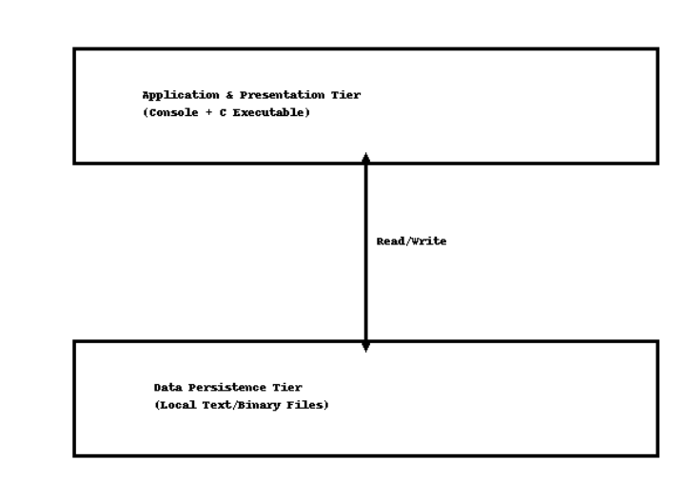
Figure 5.1: System Architecture Diagram

The tiers are: Tier 1: Application and Presentation Tier (the C executable handling all logic and the console menu), and Tier 2: Data Persistence Tier (the local text files used for persistent storage).

5.2 Procedure Oriented
The Procedure-Oriented Design (POD) approach is suitable for the C programming paradigm, emphasizing functional decomposition and efficient data flow between modules (Booch et al., 2005).

5.2.1 Data Flow Diagram
Data Flow Diagrams (DFDs) graphically represent the system's processes and the flow of data between external entities, internal processes, and data stores.

5.2.2 Context Level (Level 0) DFD
The Context Level DFD defines the boundary of the Console-Based Educational Tool, showing its high-level interaction with external entities: the Student/User (receives information) and the Administrator (manages data).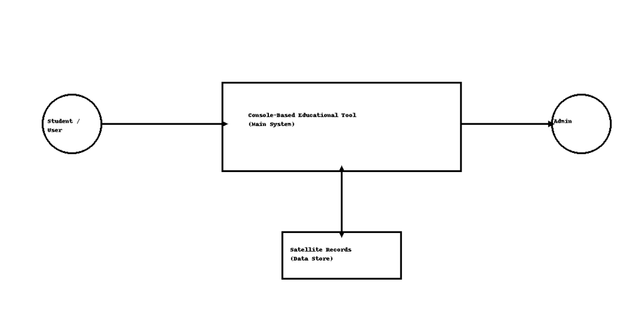
Figure 5.2: Context Level (Level 0) DFD

5.2.3 Level 1 DFD
The Level 1 DFD decomposes the single context process into the major functional sub-processes required for the application: Display Information (1.0) and Manage Data (2.0), interacting with D1: Satellite Records.
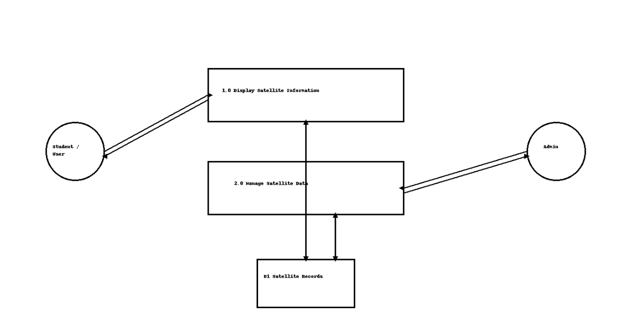
Figure 5.3: Level 1 DFD

5.2.4 Use Case Diagram
The Use Case Diagram visually identifies the system's key functional requirements (use cases) and the actors who initiate them.
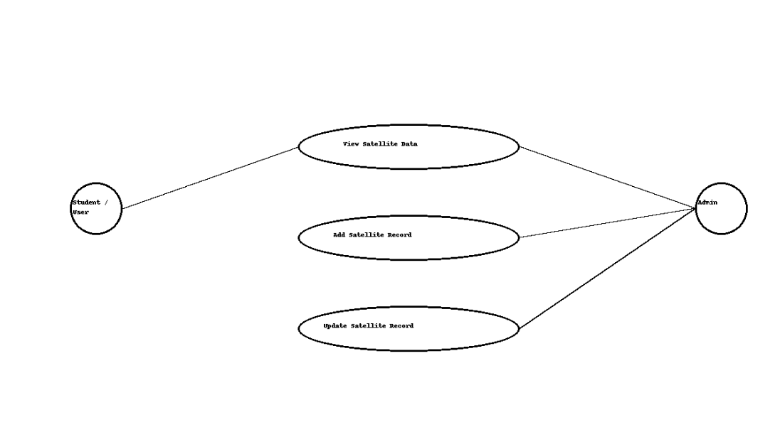
Figure 5.4: Use Case Diagram
The primary use cases are: View Satellite Data (Student/User, Administrator), Add Satellite Record (Administrator only), and Update Satellite Record (Administrator only).

5.4 Database Design
The data persistence model relies on a structured format equivalent to a single flat file.

5.4.1 ER Diagram
The Entity-Relationship (ER) Diagram defines the core entity, Satellite Record, and its structural attributes, matching the C struct Satellite definition.
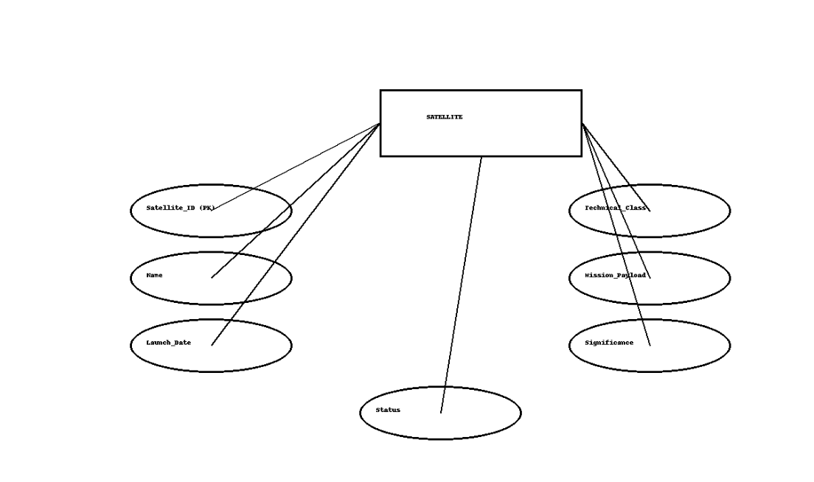Figure 5.5: ER Diagram

5.4.2 Data Dictionary
The Data Dictionary formally defines the structure of the Satellite entity, matching the data types used in the C implementation.
Table 5.1: Data Dictionary for Satellite Records
Field Name | Data Type (C equivalent) | Size/Length | PK/FK | Nullable | Unique | Description
Satellite_ID | int | 10 | PK | N | Y | Unique ID for the record.
Name | char[] (string) | 50 | - | N | N | Official name of the satellite.
Launch_Date | char[] (string) | 12 | - | N | N | Date of launch (YYYY-MM-DD format).
Technical_Class | char[] (string) | 30 | - | N | N | Classification (e.g., CubeSat).
Mission_Payload | char[] (string) | 250 | - | N | N | Primary objectives and key instruments.
Space Agency | char[] (string) | 500 | - | N | N | Space Agency launching the Satellites
Satellite Identifier number | char[] (string) | 500 |  | N | Y | Satellite Identifier Code provided by Space Agency
Status | char[] (string) | 20 | - | N | N | Operational status (Active, Upcoming).

6 System Development and Implementation
This chapter focuses on the execution phase of the Software Development Life Cycle (SDLC), detailing the Programming Platform utilized for coding and the Operating Environment required to run the final compiled application. Adherence to the procedural paradigm ensured a systematic and efficient implementation process.

6.1 Programming Platform
The core development activities—coding, compiling, and debugging—were performed using a stable, widely available open-source toolchain to maintain the project's non-functional requirement for cost-effectiveness and cross-platform portability.
Environment Component | Specification | Purpose in Project
Primary Language | C Programming Language (C99 Standard) | Used to implement all core logic, data structures (struct Satellite), and file I/O operations.
Compiler | GNU Compiler Collection (GCC 11.2.0 or later) | Selected for its reliability, optimization capabilities, and universal availability across Linux, Windows (via MinGW/Cygwin), and macOS.
IDE/Editor | Visual Studio Code (VS Code) | Used for efficient source code management, syntax highlighting, and integrated debugging during the implementation phase (Weeks 3-5).
Version Control | Git / GitHub (Repository: Regmisushil/test/developement) | Used to manage collaboration, track development history, and ensure systematic rollback capabilities throughout the implementation and testing phases.
The consistent use of the C99 standard and standard libraries ensured that the code remained purely procedural, fulfilling the design constraints established in Chapter 3.

6.2 Operating Environment
The Operating Environment specifies the minimum hardware and software required to run the final compiled executable file (the console application). Given the design, the requirements are minimal, maximizing accessibility for educational purposes.

Hardware Requirements
- Processor: Any x86/x64 compatible processor (e.g., Intel Core 2 Duo equivalent or better).
- RAM: Minimum 512 MB of free RAM.
- Storage: Minimal disk space (less than 1 MB) for the executable file and local data storage files.

Software Requirements
- Operating System: Windows 7/10/11, any modern Linux Distribution (e.g., Ubuntu, Fedora), or macOS.
- Runtime Environment: Access to a standard terminal or console emulator (e.g., Command Prompt).
- Dependencies: No external runtime libraries or frameworks are required. The executable is standalone.
- Microsoft SQL server: For database management and persistence
The minimal operating requirements confirm the project’s success in achieving the primary objective of creating an accessible, low-resource educational tool suitable for deployment in typical educational labs and older computing hardware.

7 Testing and Debugging
Testing and debugging constituted a critical phase (Week 6) of the Software Development Life Cycle for the Console-Based Educational Tool. This phase was designed to systematically verify that the application meets all defined Functional Requirements (FRs) and operates robustly within its specified Non-Functional Requirements (NFRs). The focus was on validating the core logic: the data manipulation functions (Add, Update) and the data persistence mechanism (File I/O).
The testing approach was primarily Black-Box Testing, focusing on the user interface (the console menu) and inputs, and Unit Testing, ensuring individual C functions (like the function to load data from the file) executed correctly.

7.1 Tools Used in Testing
The tools utilized were selected for their accessibility and suitability for a C console-based application, requiring no specialized, licensed software.
Table 7.1: Tools Used in Testing
S.N. | Tool | Specifications
1. | Hardware (Computer/ Laptop/Mobile) | Standard Laptops/Desktops with 4GB+ RAM for execution environment testing.
2. | Terminal Emulators | Windows Command Prompt (CMD)
3. | Debugging Software | GCC GDB (GNU Debugger) integrated within VS Code IDE.
4. | Manual Testing | Direct command-line input validation and output inspection.

7.2 Test Cases
The following test cases target the core functional requirements (F1, F3, F4) related to information display and data management.
Table 7.2: Test Cases for Core CRUD Functionality
ID | Test Case Description | Test Case Data | Expected Result | Actual Result | Status
T-01 | Add New Valid Record: Test the successful addition of a complete, new satellite record (F3). | Name: 'Danfe'  Class: 'Photography'  LaunchDate: '2025-10-01'  Payload: 'Visual Camera'  Agency: 'NASA'  IDN: '1990-037B'  Status: 'Active' | System displays "Record Added Successfully" and Danfe appears in the View All list. | Meets expectation | Pass
T-02 | Update Existing Status: Modify the status of a known existing satellite (F4). | IDN: '1990-037B' (NepaliSat-1), Field to Update: Status, New Value: 'Decommissioned'. | System confirms update, and View Detailed Profile shows the new 'Decommissioned' status. | Working as Expected | Pass
T-03 | Read Valid Detailed Profile: View full technical specifications of a pre-loaded satellite (F2). | IDN: '1990-037B' (NepaliSat-1), | Full record fields (Mission and Payload, Class,Identifier,Space Agency, status) are displayed without truncation or error. | Working as Expected | Pass
T-04 | Input Validation (Launch Date)  Attempt to input launch date in invalid format or invalid date  :). | Launch Date (DD-MM-YYYY): '2024-01-01'. | System rejects the input, displays an error message ("Invalid Date Format"), and prompts for re-entry. | Working as Expected | Pass
T-05 | Data Persistence Test: Verify that data written in a previous session is loaded correctly upon startup. | Pre-added record T-01 ('Danfe') is added, system is closed and reopened. | View All list confirms the presence of the 'Danfe' record after restart. | Working as Expected | Passed

8. Conclusion
This project successfully culminated in the design and implementation of a Console-Based Educational Tool, fulfilling all the objectives set forth in the introduction. The core problem—the fragmentation and low accessibility of information regarding Nepalese satellites—was effectively addressed and solved.
The development verified that a cost-effective, Procedure-Oriented approach using C programming can deliver a robust and functional data management solution. Specifically:
- Objectives Met: The project successfully created an interactive learning environment via the console interface and provided dynamic content through the Add/Update features, thereby enabling the dissemination of information about both existing (NepaliSat-1, SanoSat-1) and upcoming (Danfe, Munal) satellites.
- Significance Verified: The creation of this tool directly fills the educational resource gap identified in the Literature Review (Chapter 2). Its minimal operating environment confirms its high portability and accessibility, making it immediately viable for use in diverse educational settings with limited hardware resources.
- Design Validity: The Procedure-Oriented Design (Chapter 5) proved to be the optimal architectural choice, delivering stability and speed, which aligns perfectly with the project's constrained scope and budget.
The Console-Based Educational Tool stands as a proof of concept, demonstrating that national technological achievements can be documented and utilized as inspirational educational material through simple, well-structured software.

9 References
Kernighan, B. W., & Ritchie, D. M. (2013). The C programming language (2nd ed.). Prentice Hall International. ISBN: 978-0131103627.
McConnell, S. (2004). Code complete: A practical handbook of software construction (2nd ed.). Microsoft Press. ISBN: 978-0735619678.
Sommerville, I. (2015). Software engineering (10th ed.). Pearson Education Limited. ISBN: 978-0133943038. https://doi.org/10.1109/TSE.2015.2406977
International Organization for Standardization. (2011). Systems and software engineering—Architecture description (ISO/IEC/IEEE 42010:2011). ISO.
Robins, A., Rountree, J., & Rountree, N. (2003). Learning and Teaching Programming: A Review and Discussion. Computer Science Education, 13(2), 137-172. https://doi.org/10.1076/csed.13.2.137.142002), 137-172. DOI: 10.1076/csed.13.2.137.14200.
Pressman, R. S. (2010). Software Engineering: A Practitioner's Approach (7th ed.). McGraw-Hill. ISBN: 978-0073375342.
Booch, G., Rumbaugh, J., & Jacobson, I. (2005). The Unified Modeling Language User Guide (2nd ed.). Pearson Education. ISBN: 978-0321267979.

